• Submission Checklist
Make single docx file with all labeled screenshots.
1. MongoDB Console Screenshots:
- Provide screenshots of your MongoDB database showing collections.

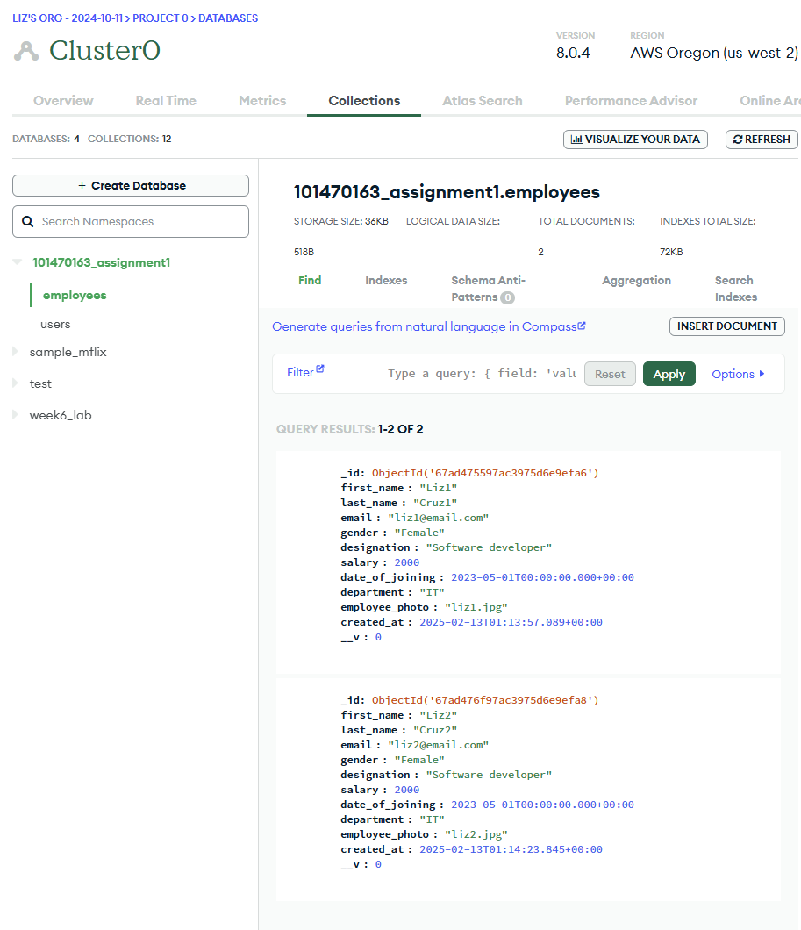

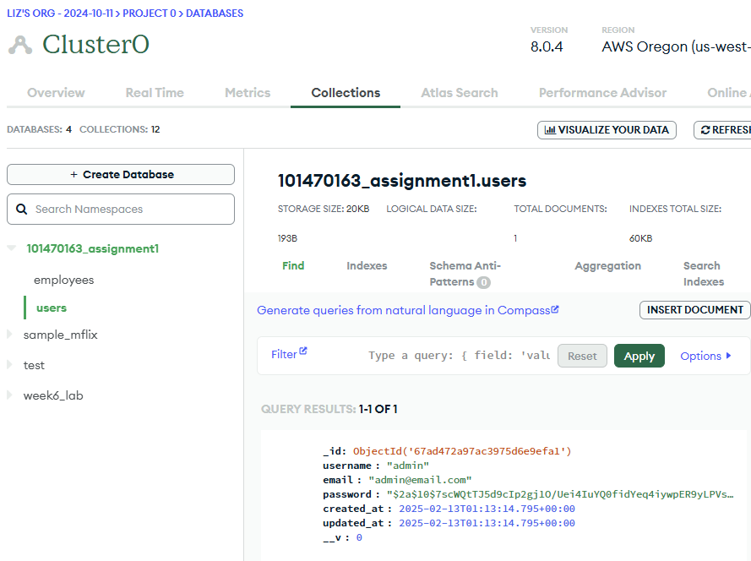
2. Postman API Collection:
- Export your Postman collection and include it in your submission.
Done

3. Screenshots:
- Include screenshots of each API being tested along with responses.
- User registration
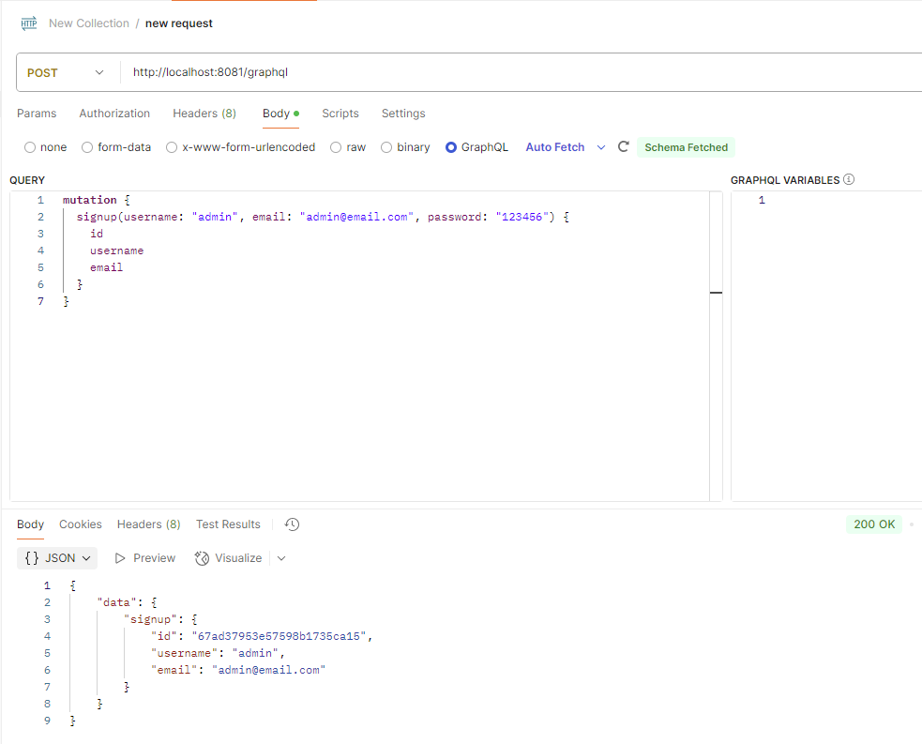

- Login
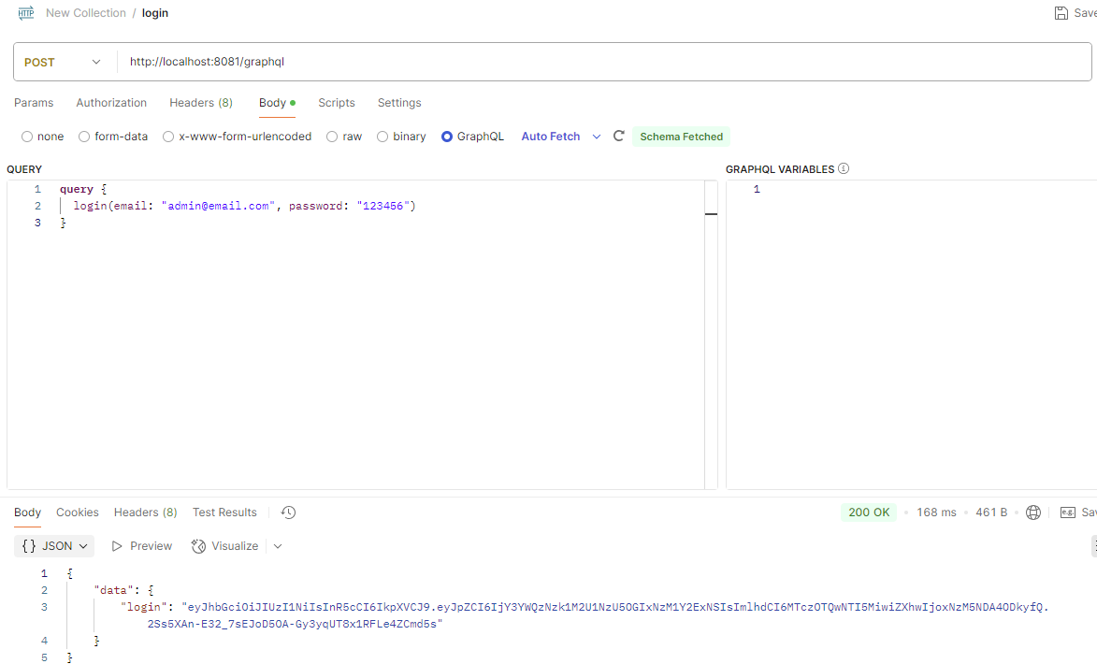

- Create employee
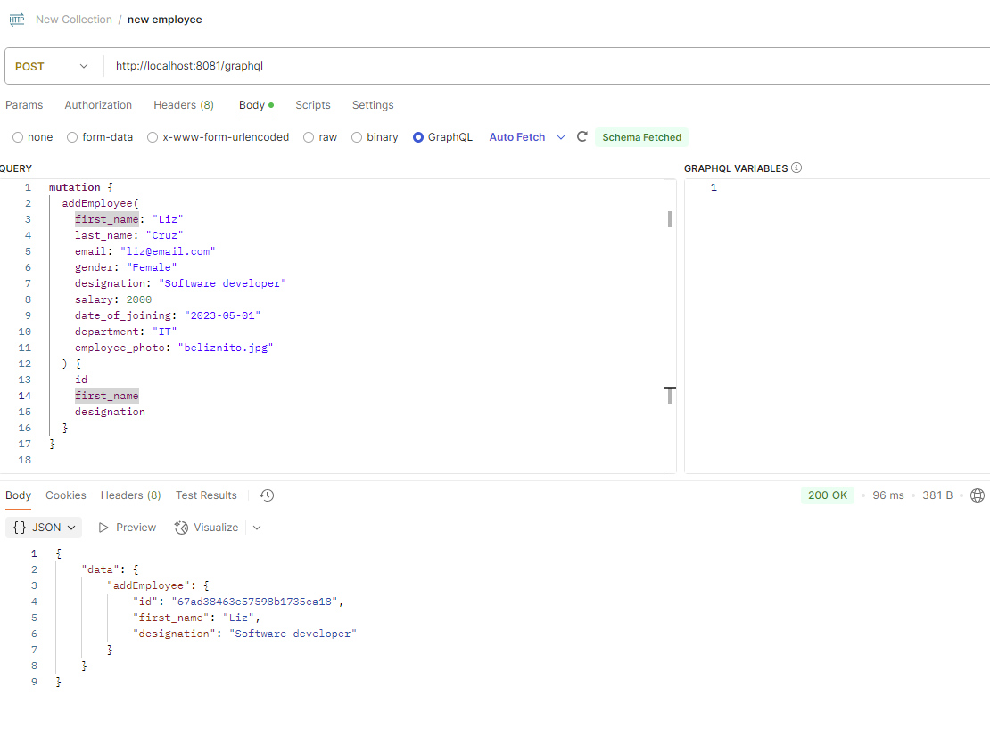

- Check all employees
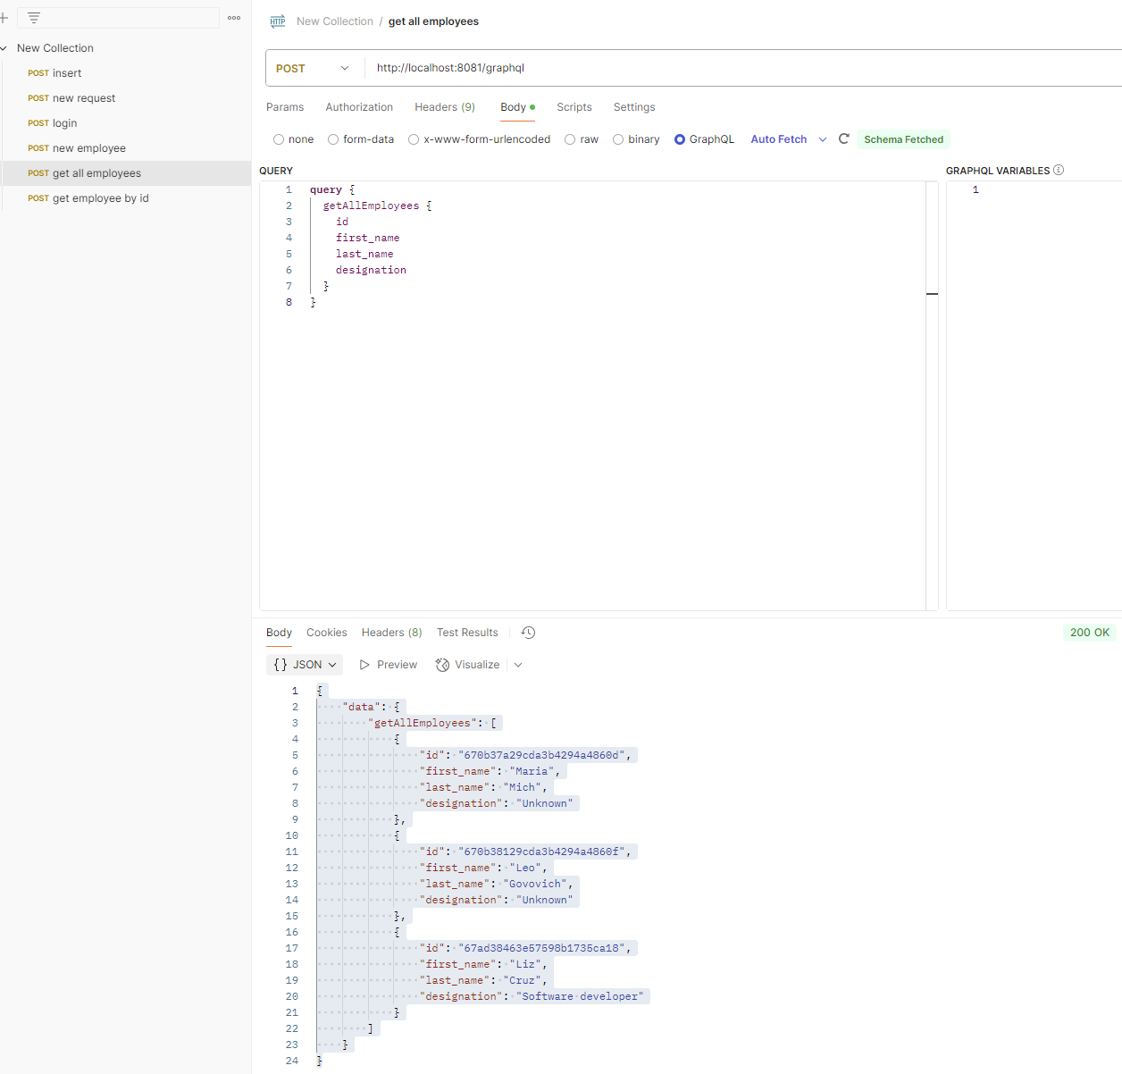

- Employee by ID
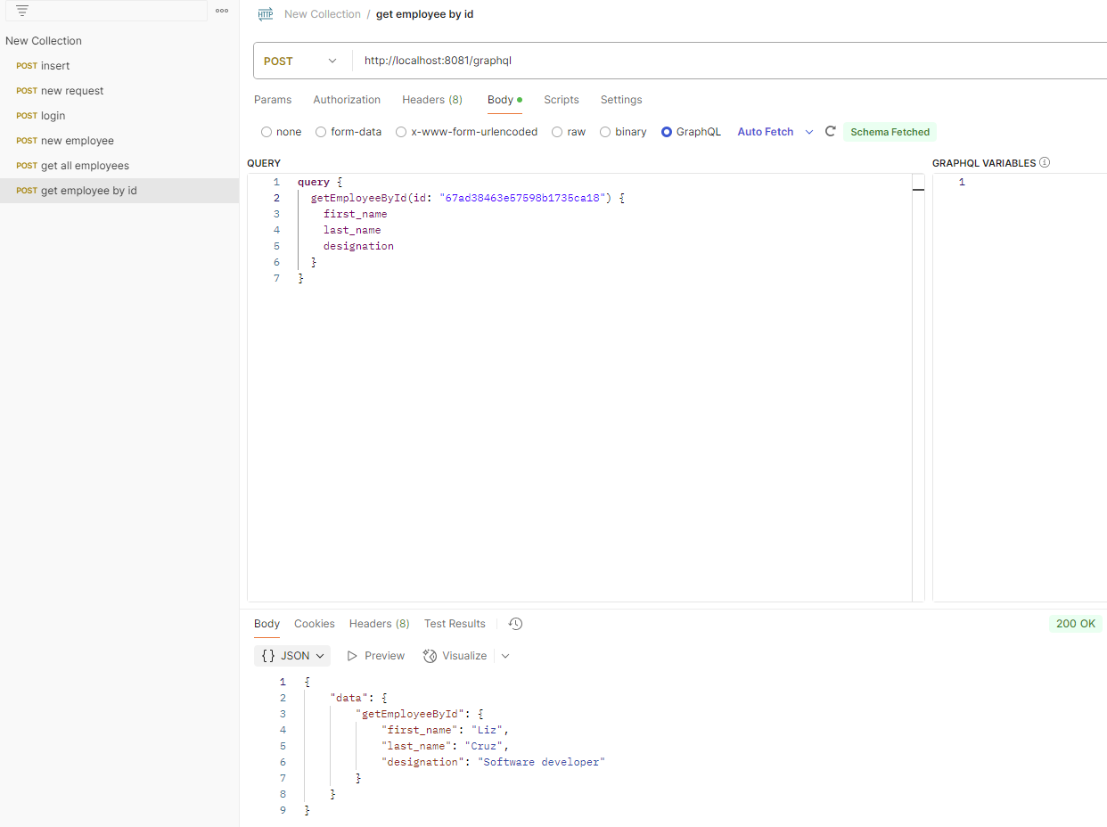

- Employee by designation
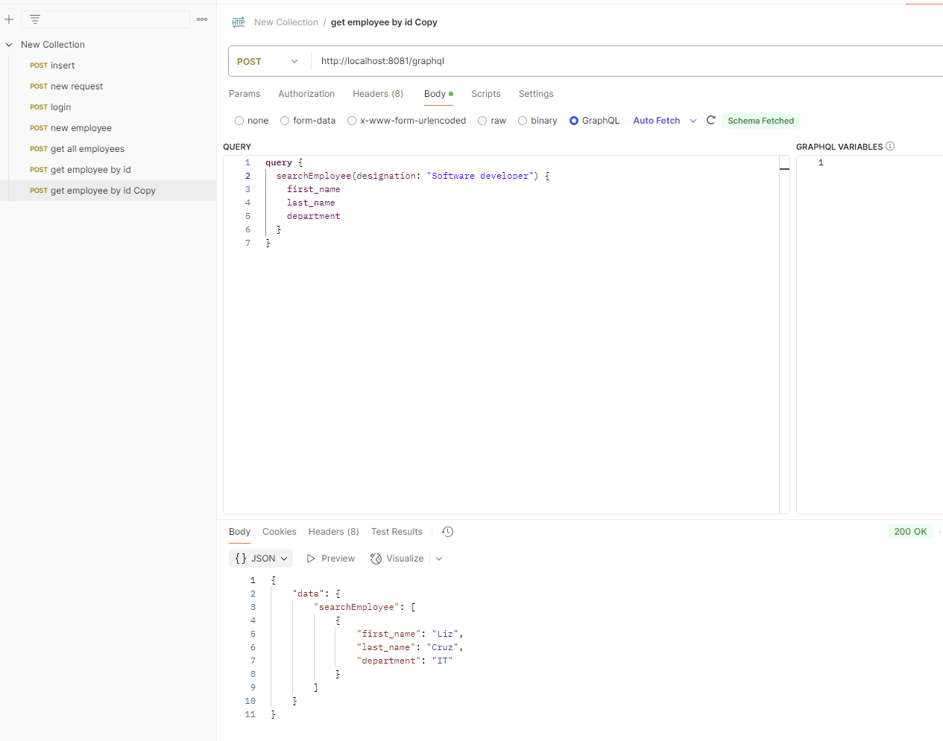

- Update employee
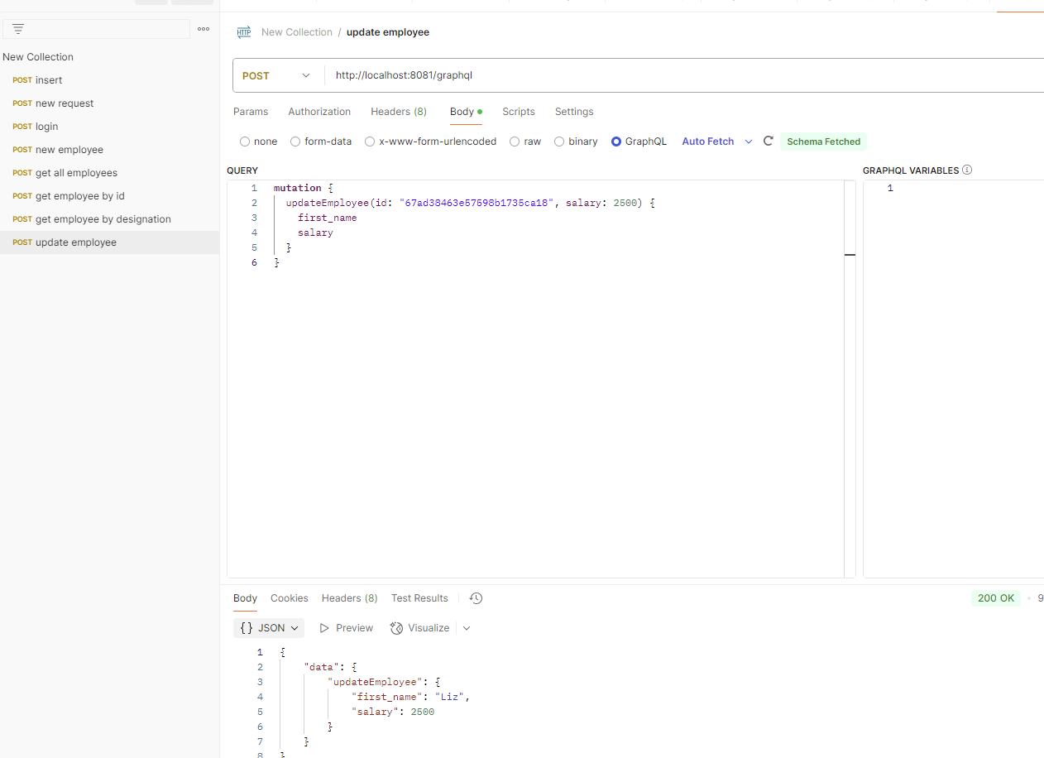

- Delete employee
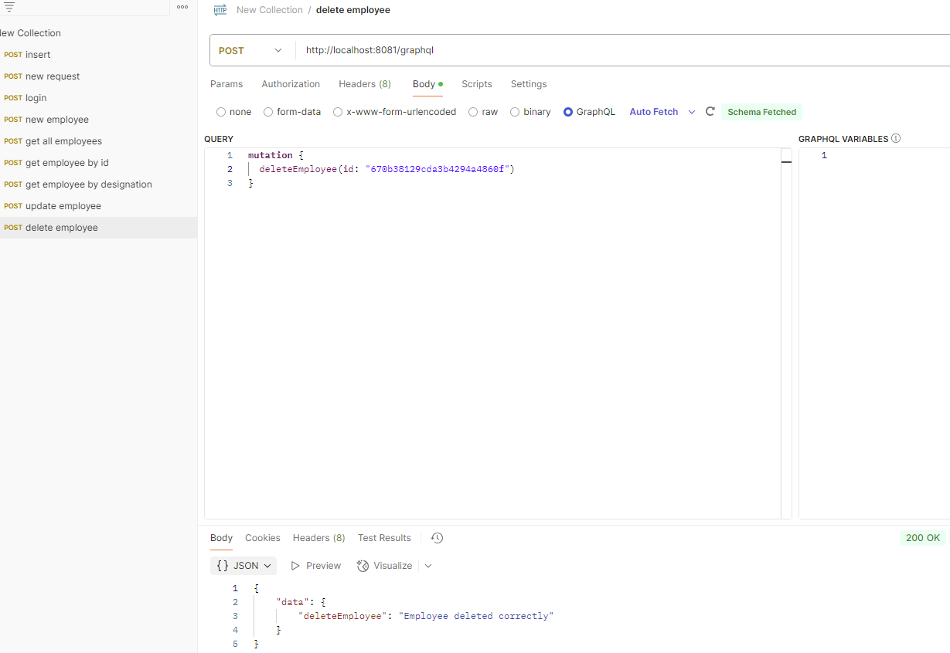

- Email Validation

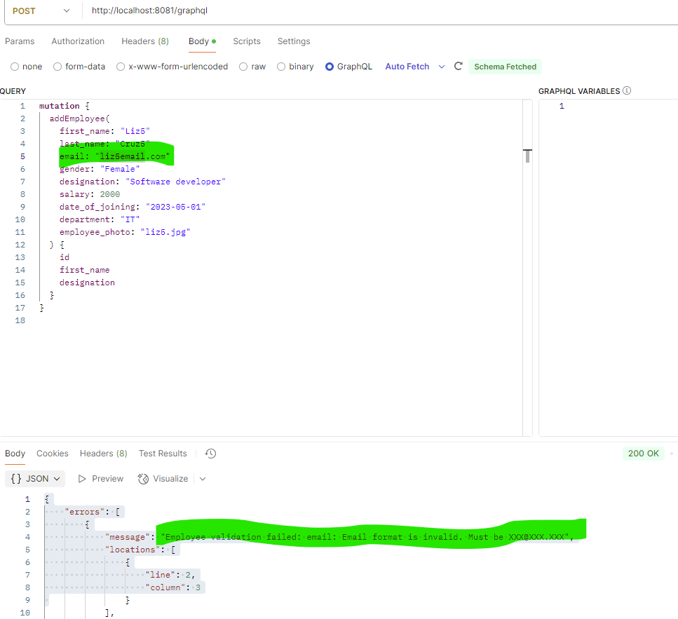
4. Project ZIP File:
- Remove the node_modules folder and create a ZIP file of your project.
Done
5. GitHub Project Link:
- Provide the link to your GitHub repository.
6. Sample User Detail:
- Include a sample user’s details for testing login.
1. Create User
mutation {
signup(username: "admin", email: "admin@email.com", password: "123456") {
id
username
email
}
}

2. Login

query {
login(email: "admin@email.com", password: "123456")
}

7. Comments:
- Add any comments or notes that could be helpful.
Done















